|  |  |  |  |  |  |  |  |  |
| --- | --- | --- | --- | --- | --- | --- | --- | --- |
|  | | | | | | | | |
|  | | AWS Lab 3 | | | | |  | |
|  |  | | | | | | |  |
|  | | | |  |  | | | |
|  | | | | Weizhen Chen |  | | | |
|  | | | | —CCNP—Jeffery Mason &Michael Hansen |  | | | |
|  | | |  | | |  | | |

# Lab 3: Introduction to Amazon EC2

**Amazon Elastic Compute Cloud (Amazon EC2)** is a web service that provides resizable compute capacity in the cloud. It is designed to make web-scale cloud computing easier for developers. It allows you to obtain and configure capacity with minimal friction, provides you with complete control of your computing resources and lets you run on Amazon's proven computing environment. Amazon EC2 reduces the time required to obtain and boot new server instances to minutes, allowing you to quickly scale capacity, both up and down, as your computing requirements change. It allows you to pay only for the capacity that you use. Amazon EC2 provides developers the tools to build failure resilient applications and isolate themselves from common failure scenarios.

**The purpose**

Learn the basics overview of launching, resizing, managing, and monitoring an Amazon EC2 instance. After completing this lab, you can Launch a web server with termination protection enabled, Monitor Your EC2 instance, Modify the security group that your web server is using to allow HTTP access, resize your Amazon EC2 instance to scale, Explore EC2 limits, Test termination protection, Terminate your EC2 instance.

**Task 1: Create an AMI for Auto Scaling**

1. In the **AWS Management Console** in the search box to the right of **Services**, choose **Compute** and then choose **EC2**.
2. Choose **Launch instances**

**Step 1: Name and tags**

1. Give the instance the name Web Server

**Step 2: Application and OS Images (Amazon Machine Image)**

1. In the list of available *Quick Start* AMIs, keep the default **Amazon Linux** AMI selected.
2. Keep the default **Amazon Linux 2 AMI (HVM)** selected.

**Step 3: Instance type**

1. In the *Instance type* panel, keep the default **t2.micro** selected.

### **Step 4: Key pair (login)**

1. For **Key pair name - *required***, choose **vockey**.

### **Step 5: Network settings**

1. Next to Network settings, choose **Edit**.
2. For **VPC**, select **Lab VPC**.
3. Under **Firewall (security groups)**, choose **Create security group** and configure:

* **Security group name:** Web Server security group
* **Description:** Security group for my web server

### **Step 6: Configure storage**

1. In the *Configure storage* section, keep the default settings.

### **Step 7: Advanced details**

1. Expand **Advanced details**.
2. For **Termination protection**, select **Enable**.
3. Scroll to the bottom of the page and then copy and paste the code

**Step 8: Launch the instance**

1. At the bottom and choose **Launch instance**
2. Choose **View all instances**
3. Wait for your instance to display the following:

* **Instance State:** *Running*
* **Status Checks:** *2/2 checks passed*

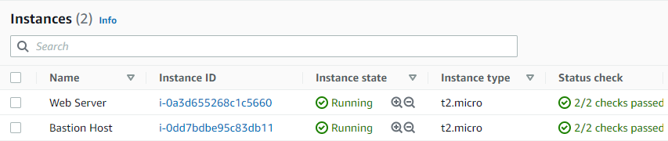

## Task 2: Monitor Your Instance

1. Choose the **Status Checks** tab
2. Choose the **Monitoring** tab
3. In the **Actions** menu towards the top of the console, select **Monitor and troubleshoot** to **Get system log**.
4. Scroll through the output and note that the HTTP package was installed from the **user data**
5. Choose **Cancel**.

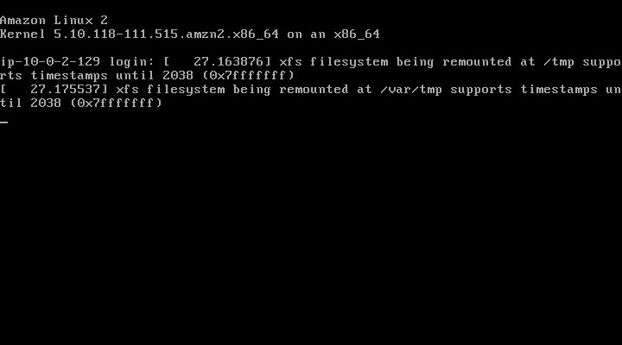

## Task 3: Update Your Security Group and Access the Web Server

1. Ensure **Web Server** is still selected. Choose the **Details** tab.
2. Copy the **Public IPv4 address** of your instance to your clipboard.
3. Paste the IP address you just copied, then press **Enter**.
4. In the left navigation pane, choose **Security Groups**.
5. Choose the **Inbound rules** tab.
6. Choose **Edit inbound rules**, select **Add rule** and then configure:

* **Type:** *HTTP*
* **Source:** *Anywhere-IPv4*
* Choose **Save rules**

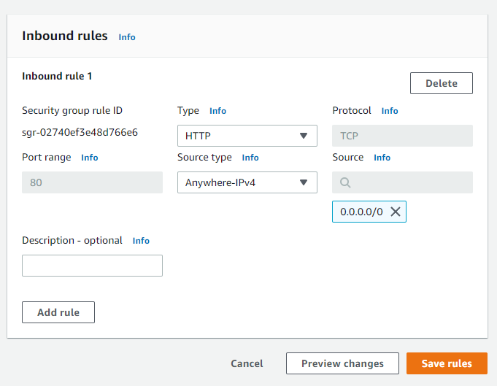

1. Return to the web server

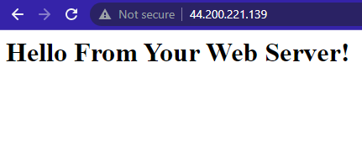

## Task 4: Resize Your Instance: Instance Type and EBS Volume

**Stop Your Instance**

1. On the **EC2 Management Console**, in the left navigation pane, choose **Instances, select Web Server**
2. In the **Instance State** menu, select **Stop instance** and choose **Stop**
3. Wait for the **Instance State** to display Stopped

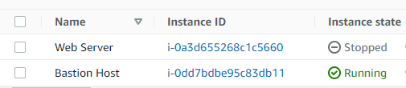

**Change The Instance Type**

1. In the **Actions** menu, select **Instance settings** **Change instance type**, then configure:

* **Instance Type:** *t2.small*
* Choose **Apply**

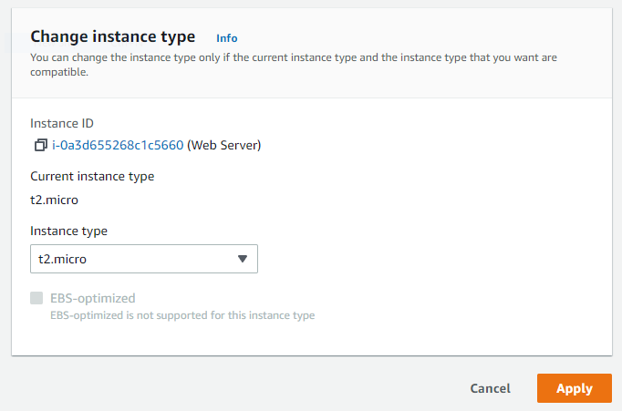

**Resize the EBS Volume**

1. Choose the **Storage** tab, select the name of the Volume ID, then select the checkbox next to the volume that displays.
2. In the **Actions** menu, select **Modify volume**.
3. Change the size to: 10
4. Choose Modify

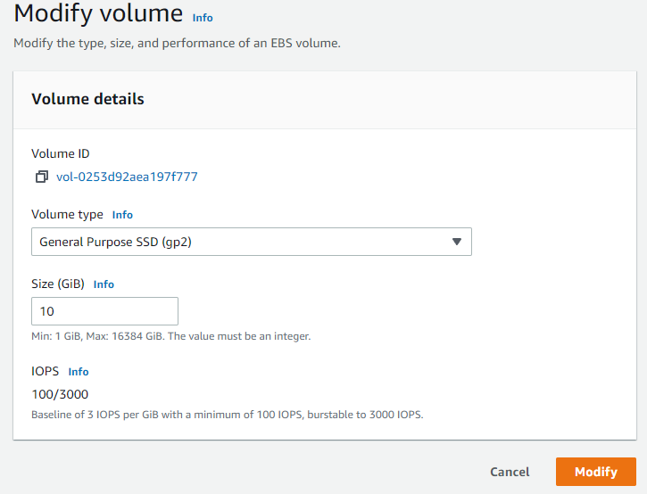

**Start the Resize Instance**

1. In the left navigation pane, choose **Instances**.
2. Select the **Web Server** instance.
3. In the **Instance state** menu, select **Start instance**.

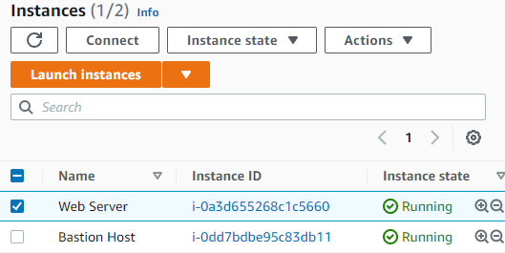

## Task 5: Test Termination Protection

1. In left navigation pane, choose **Limits**
2. From the **All Limits** drop down list, choose **Running instances**.

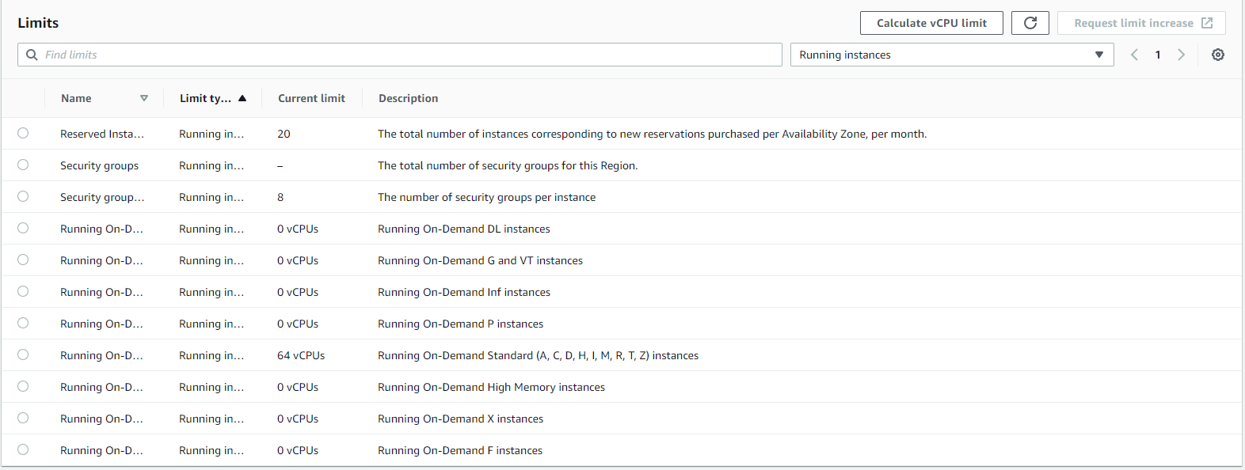

## Task 6: Test Termination Protection

1. In left navigation pane, choose **Instances**.
2. Select the Web Server in the Instance state, select **Terminate instance**
3. Choose **Terminate**

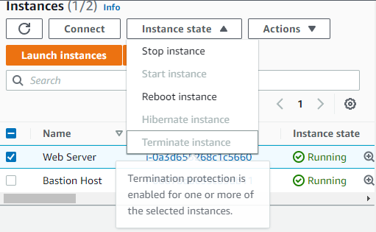

1. In the **Actions** menu, select **Instance settings** **Change termination protection**.
2. Uncheck **Enable**
3. Choose **Save**
4. Select the **Web Server** instance again and in the **Instance state** menu, select **Terminate instance**.
5. Choose **Termina**

